**Laptop Harbor**



**GROUP MEMBERS:**

**ROHAIL LAZARUS**

***Student1391529***

**BUSHRA**

***Student1412223***

**SAMIULLAH**

***Student1429988***

**SYED HUMAYOON AZIZ**

***Student1430859***

**AHMED MUJTABA SHAHZAD**

***Student1397463***

**EMAAN AMEEN**

***Student1440270***

**CURRICULUM**

**7062**

**BATCH**

**2211B1**

**FACULTY**

**SIR USAMA RIAZ**

**CO-ORDINATOR**

**MS MUNAZZAH**

**Laptop Harbor**

IS SUBMITTED BY

**ROHAIL LAZARUS**

***Student1391529***

**BUSHRA**

***Student1412223***

**SAMIULLAH**

***Student1429988***

**SYED HUMAYOON AZIZ**

***Student1430859***

**AHMED MUJTABA SHAHZAD**

***Student1397463***

**EMAAN AMEEN**

***Student1440270***

SCREEN SHOTS:

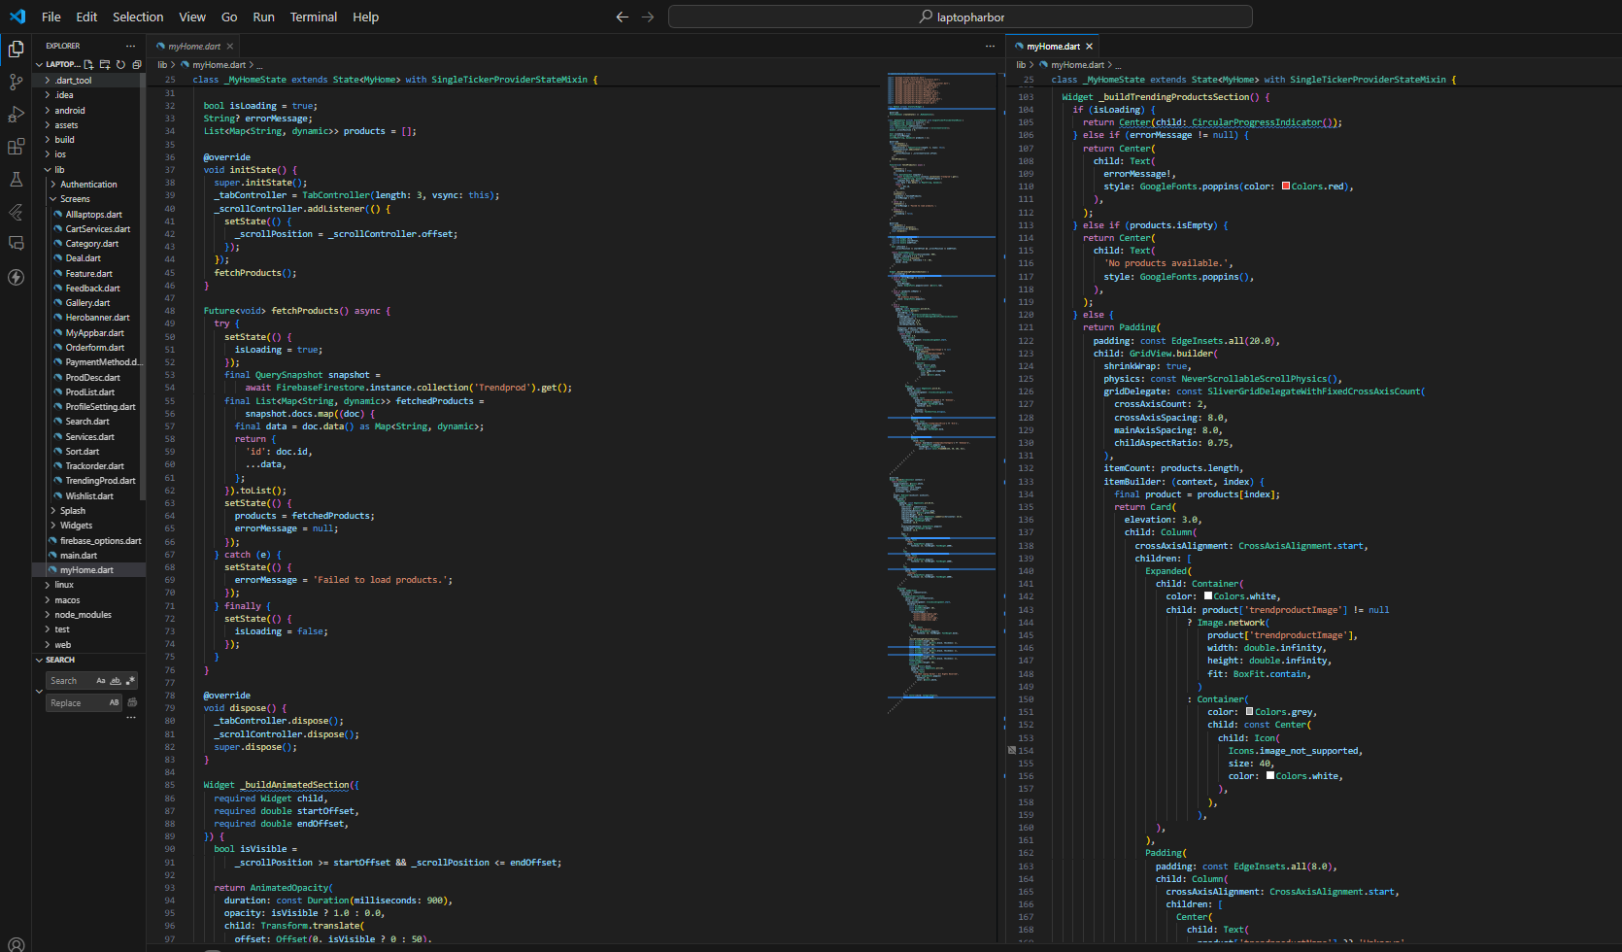HOME PAGE CODE:

DISPLAY USER:

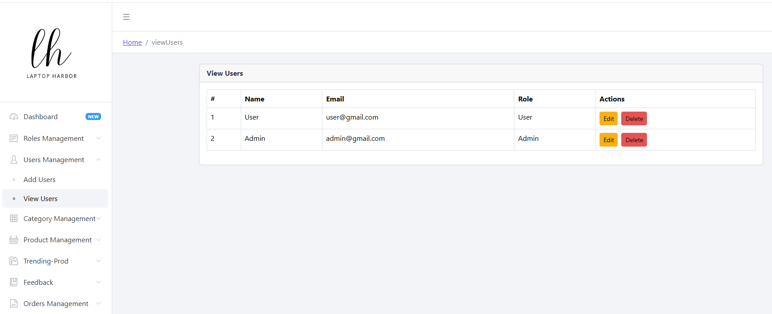

DISPLAY ROLES:

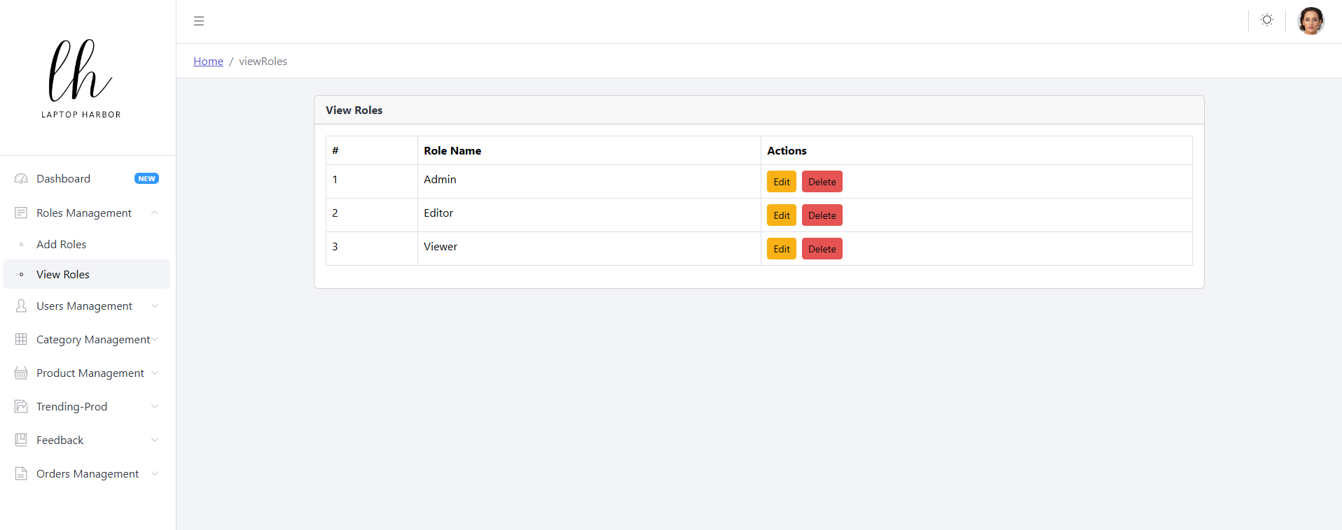

DISPLAY ADDED CATEGORIES:

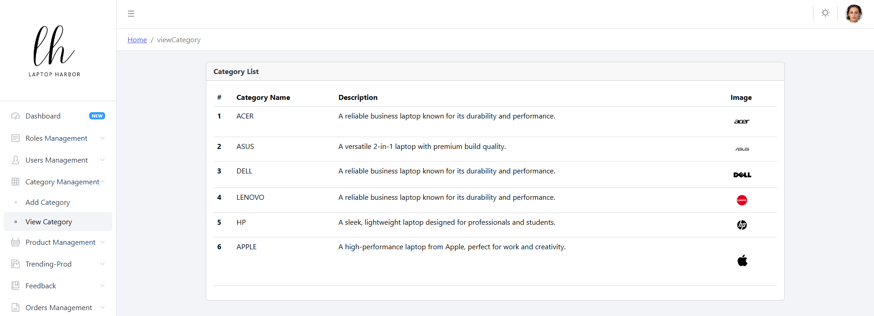

DEALS CODE:

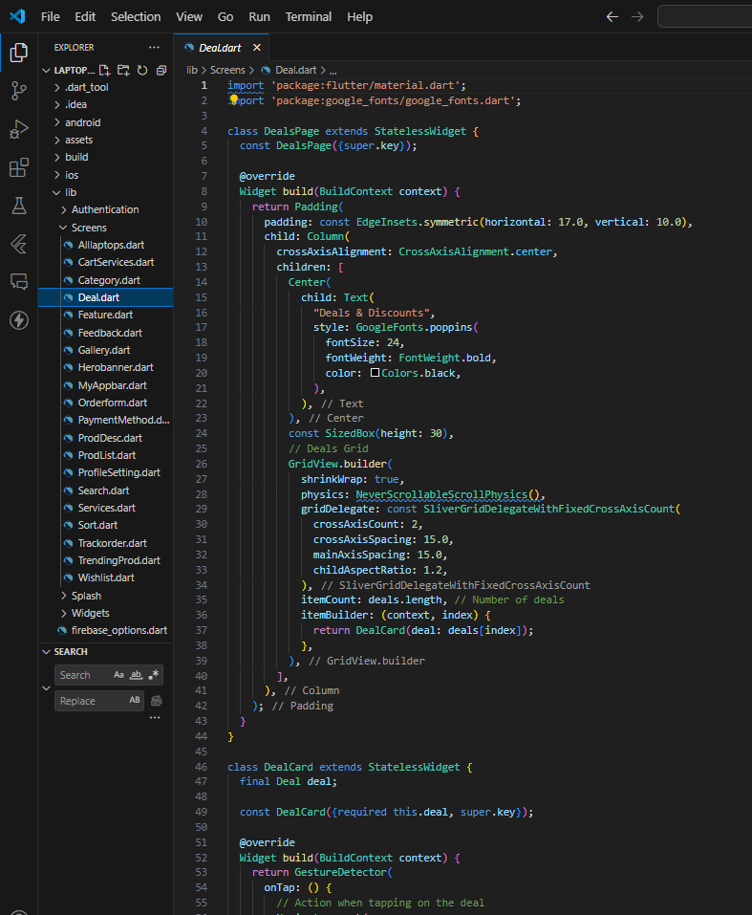

FEATURED PRODUCTS CODE:

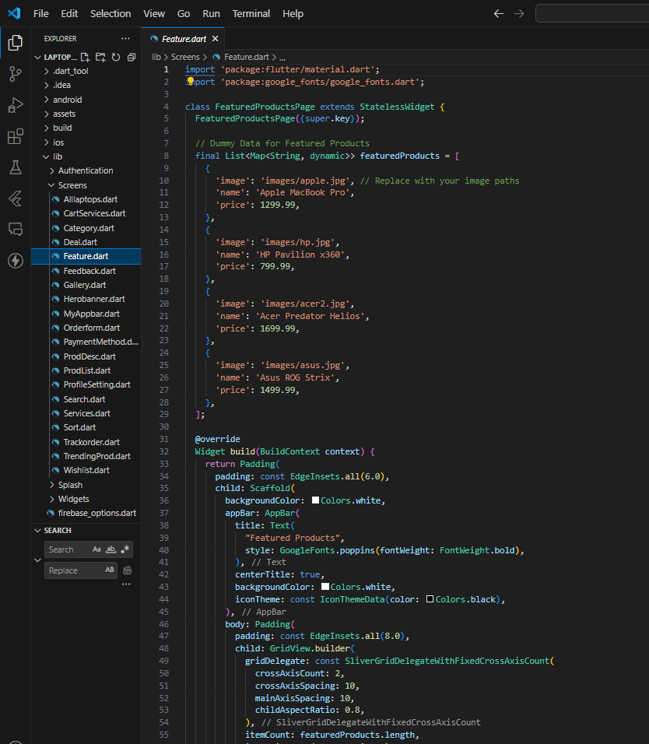

SUBMISSION CHECKLIST:

|  |  |  |  |
| --- | --- | --- | --- |
| **S#** | **LIST OF ITEMS** | **REMARKS** | **COMMENTS** |
| **1.** | Do All Pages link together? | **YES** | ✓ |
| **2.** | Authorization | **YES** | ✓ |
| **3.** | CRUD Operations | **YES** | ✓ |
| **4.** | Database Connection | **YES** | ✓ |
| **5.** | Feedback form included | **YES** | ✓ |
| **6.** | Project ZIP file | **YES** | ✓ |

### CONCLUSION:

In conclusion, the symbiotic relationship between computer software and hardware is indispensable for efficient operation. System requirements serve as a crucial guide, delineating the necessary components and resources for optimal performance. Yet, they are not rigid mandates but rather flexible benchmarks that adapt to evolving technological landscapes. As software evolves to harness more processing power and resources, system requirements inevitably escalate, prompting users to upgrade their systems. This trend underscores the pivotal role of software demands in driving technological advancements and system upgrades. Thus, understanding and accommodating system requirements remain imperative for navigating the ever-changing realm of computing.